UNIT IV

**Multiple Access Techniques**

* **Frequency Division Multiple Access (FDMA)**
* **Time Division Multiple Access (TDMA)**
* **Code Division Multiple Access (CDMA)** 
  + **Direct Sequence CDMA**

**Since the RF spectrum is a finite and limited resource, it is necessary to share the available resources between users**

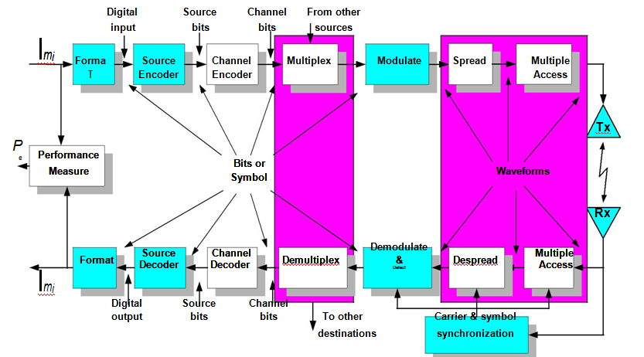

*Duplexing*

A technique commonly used in many radio and telecommunication between a pair of users – Tx and Rx

* **Simplex**

– Information is transmitted in one and only one pre-assigned direction\

|  |  |  |  |  |  |  |  |  |  |  |
| --- | --- | --- | --- | --- | --- | --- | --- | --- | --- | --- |
| **Terminal A** |  |  |  |  |  |  |  | **Terminal B** | **Simplex** |  |
|  |  |  |  |  |  |  |  |
|  |  |  |  |  |  |  |  |
|  |  |  |  |  |  |  |  |  |  |  |
|  |  |  |  |  |  |  |  |  |  |  |
| **Terminal A** |  |  |  |  |  |  |  | **Terminal B** | **Half-duplex** |  |
|  |  |  |  |  |  |  |  |
|  |  |  |  |  |  |  |  |
|  |  |  |  |  |  |  |  |  |  |  |
|  |  |  |  |  |  |  |  |  |  |  |
| **Terminal A** |  |  |  |  |  |  |  | **Terminal B** | **Full-duplex** |  |
|  |  |  |  |  |  |  |  |
|  |  |  |  |  |  |  |  |  |  |  |



 **Half Duplex**

– Transmission of information in only one direction at a time

– Uses simplex operation at both end

* **Full Duplex**

– Simultaneous transmission and reception of info in both directions

– In general, duplex operation require 2 frequencies

– May be achieved by simplex operation of 2 or more simplex at both ends

• Duplexing can be implemented in either Frequency or Time domain

– Frequency Division Duplexing (FDD) & Time Division Duplexing (TDD)

|  |  |  |  |  |  |  |  |  |  |  |  |
| --- | --- | --- | --- | --- | --- | --- | --- | --- | --- | --- | --- |
|  |  |  |  |  |  |  |  |  |  |  |  |

**Frequency Division Duplexing (TDD)**

* ***Frequency Division Duplexing (FDD)***

– Multiplexes the Tx and Rx in one time slot in which transmission and reception is on 2 different frequencies

– It provides simultaneous transmission channels for mobile/base station

* + - i.e. each channel has a Forward and a Reverse frequency

– At the base station, separate transmit and receive antennas are used to accommodate the two separate channels

– At the mobile unit, a single antenna (with duplexer) is used to enable transmission and reception

– To facilitate FDD, sufficient frequency isolation of the transmit and receive frequencies is necessary

– FDD is used exclusively in analog mobile radio systems

**Time Division Duplexing (TDD)**

– Multiplexes the Tx & Rx in one frequency at different time slots

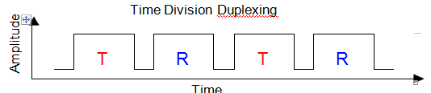

A portion of the time is used to transmit and a portion is used to receive

– TDD is used, for example, in a simple 2-way radio where a button is pressed to talk and released to listen. If the data rate from the base station >> the end-user’s data rate, it is possible to use ***buffer-and-burst*** transmission (giving the appearance of full duplex) TDD is only possible for digital transmission

*Multiplexing Techniques*

Multiplexing (sometimes called channelization) is the process of simultaneously transmitting ***several*** ***information signals*** using a single communication channelCommonly used to separate different users such that they share the same resource without interference

* Three major kinds

– **Frequency Division Multiplexing**

– **Time Division Multiplexing**

– **Code Division Multiplexing**

* Communication recourses are allocated ***a priori*** and allocated resources are ***fixed*** ***Only one pair of transceivers are required***

*Frequency Division Multiplexing*

In FDM, the available bandwidth is divided into non-overlapping frequency slots Each message is assigned a frequency slot within the available band Signals are translated to different frequency band using modulation and then added together to form a baseband signal The signals are narrowband and frequency limited .FDM can be used for either digital or analog transmission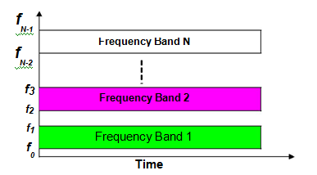

*Time Division Multiplexing (TDM)*

* Digitized info from several sources are multiplexed in time and transmitted over a single communication channel The communication channel is divided into *frames* of length *Tf* Each frame is further segmented into *N* subinterval called *slots*, each with duration *Ts* *= Tf/N*, where *N* is the number of users

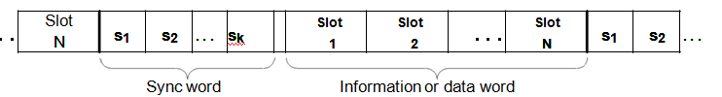

* Each user is assigned a slot (or channel) within each time frame TDM is used to combine several low bit rate signals to form a high-rate signal to be transmitted over a high bit rate medium .Individual message signals need not have the same rate, or same type of signal since each channel is independent of one another TDM is usually used for digital commun. and cannot be used in analog commun.
* *Code Division Multiplexing*

CDM is a multiplexing method where multiple users are permitted to transmit simultaneously on the same time and same frequency In CDM system, users time share a higher-rate digital channel by overlaying a higher-rate digital sequence on their transmission Each user is assigned distinct code sequence (or waveform) This technique may be viewed as a combination of FDM and TDM using some sort of code

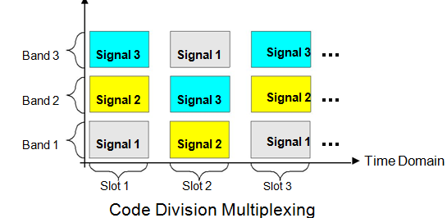

*Multiple Access Techniques*

**Definition:**

* Multiple Access (MA) techniques are multiplexing protocols that allow ***more than a pair of transceivers*** to share a common medium
* Allocation of resources

– ***not defined a priori***

– ***not necessarily fixed***

* Multiple Access can be implemented in

|  |  |  |
| --- | --- | --- |
| – | Frequency | - FDMA |
| – | Time | - TDMA |
| – | Code | - CDMA |
| – | Combinations (Frequency, Time and Code) | |

**Types of Multiple Access Techniques:**

* **Frequency Division Multiple Access (FDMA)**

– Uses different frequencies for different users

* **Time Division Multiple Access (TDMA)**

– Uses same frequency but different time for different users

* **Code Division Multiple Access (CDMA)**

– Uses same frequencies and time but different codes (3G wireless systems)

* **Space/spatial Division Multiple Access (SDMA)**

– Uses spot beam antennas to separate radio signals by pointing at different users with different spot beam, e.g., ACTS

* **Demand Access Multiple Access (DAMA)**

– Uses dynamic assignment protocol (allocates resources on request)

* **Random Access Multiple Access (RAMA)**
* **Hybrid Multiple Accesses**

– Time Division CDMA, Time Division Frequency Hopping, FDMA/CDMA, etc.

Frequency Division Multiple Access

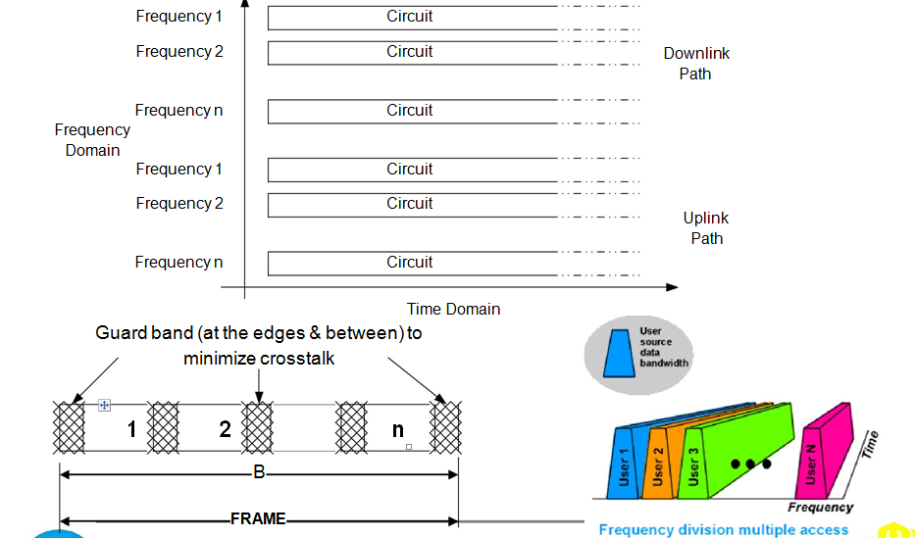

Individual frequencies are assigned to individual users on demand

* FDMA allocates a single channel to one user at a time
* Users use the channel for entire duration of call
* If the transmission path deteriorates, the controller switches the system to another channel
* Although technically simple to implement, FDMA is wasteful of BW

– Channel is assigned to a single conversation whether or not somebody is speaking

– It cannot handle alternate forms of data, only voice is permissible

* Used extensively in the early telephone and wireless multi-user communication systems

FDMA is the most commonly used access protocol especially for satellite communication

FDMA

* In a *cluster*, each user is assigned a portion of the available bandwidth

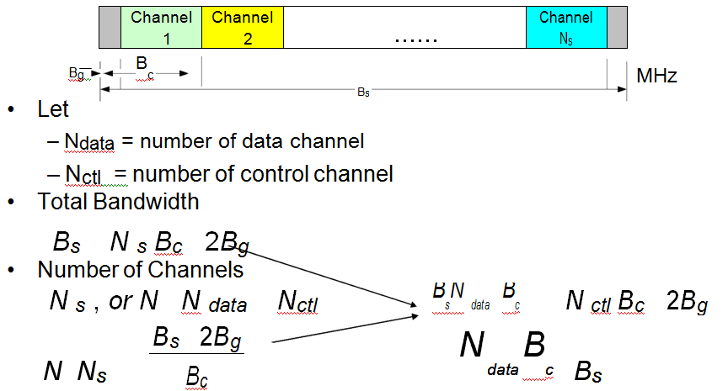

* Number of channels per cluster

*Nch* / *cluster Bs* 2*Bg*

*Bc*

* Number of channels per cell

*Nch* / *cell Nch* / *cluster*

*N*

* Number of data channels per cluster

*N data* / *cluster* *N ch* / *cluster Nctl* / *cluster*

* Number of data channels per cell

|  |  |  |  |  |
| --- | --- | --- | --- | --- |
| *Ndata* / *cell* |  | *Ndata* / *cluster* |  |  |
| *N* | |  |

Number of calls per hour per cell

*Ncalls Nch* / *cluster t* number of calls per hour

*N*

where t id the trunk efficiency

• Average number of users per hour per cell

|  |  |  |  |  |  |  |  |  |  |
| --- | --- | --- | --- | --- | --- | --- | --- | --- | --- |
| *Nuser* | | |  | number of calls/hour/cell |  |  |  |  |  |
| average # of calls/user/hour | |  |  |  |  |
|  |  |  |  |  |  |  |  |
| *FDMA* |  | BW available for data transmission | | | |  | *N data Bc* | 1 |  |
|  | | | |  |  |
|  |  |  |  | sytem bandwidth | |  | *Bs* | |  |

• Spectral Efficiency

|  |  |  |  |  |  |  |  |  |  |
| --- | --- | --- | --- | --- | --- | --- | --- | --- | --- |
|  | # of data channel/cluster | |  | *Ndata / cluster* | |  | chls/MHz/km2 | |  |
| sytem BW *A* |  |  | |  |  |
|  |  | *B* | *N A* |  | | |  |
|  | *cluster* |  |  | *s* | *cell* |  |  |  |  |

FDMA Capacity

*C* *Bs*

*N s Bc Bg*

Note that some textbooks will not account for guard bands in-between users. However, we can also have

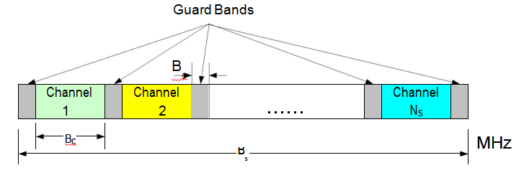

*TDMA Systems*

* Available time is divided into frames of equal duration In each time slot, only one user is allowed to either transmit or receive TDMA can operate in wideband or narrowband

– Wideband TDMA (W-TDMA)

the entire freq spectrum is available to any individual user

– Narrowband TDMA (N-TDMA)

the total available freq spectrum is divided into a number of subbands, with each subband operating as a TDMA system A user only uses the allocated subband Both frequency and time are partitioned

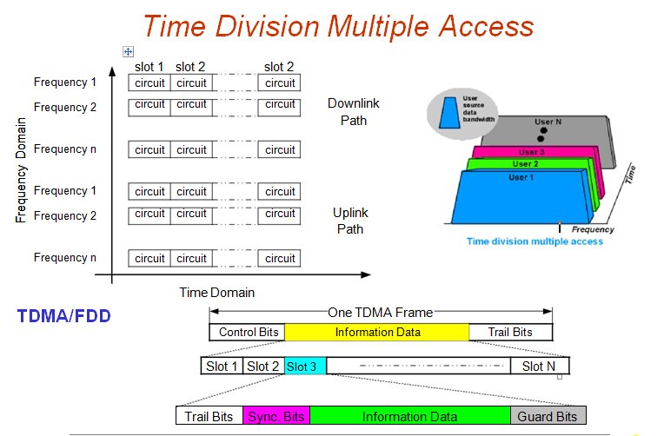

* The number of time slots per frame is a design parameter depending on requirements such as modulation, bandwidth, data rate, etc. TDMA transmits data in a ***“buffer-and-burst”*** technique and hence transmission is not continuous low battery consumption is achieved, and simplification of handoff process is achievable Transmission from users are interlaced into cyclic time structure Since different transceivers are used for communication, duplexer may not be required TDMA requires very high data rate compared to FDMA and hence equalization is not required .

***Time Division Multiple Access***

* Available time is divided into frames of equal duration

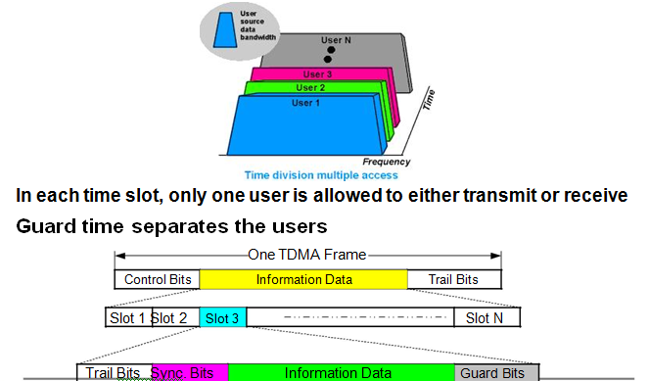

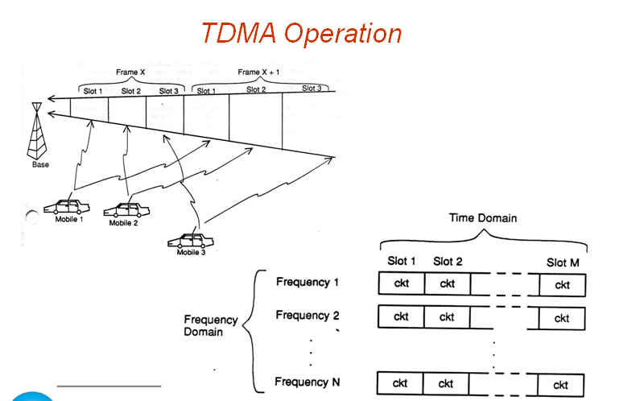

**Advantages**

* **No inter-modulation impairment**

– Since TDMA uses one carrier at a time

* **No interference from other simultaneous transmissions**

– TDMA’s technology separates users in time ensuring that they will not experience interference from other simultaneous transmissions

* **Flexibility**

– TDMA can be easily adapted for the transmission of data or voice

* **Variable rates**

– TDMA offers the ability to carry data rates of 64 kbps to 120 Mbps (expandable in multiples of 64 kbps)

– This enables operators to offer personal communication services including fax, voice-band data, and short message services as well as bandwidth-intensive applications such as multimedia and videoconferencing

* **Bandwidth efficient protocol**

– TDMA uses bandwidth more effectively because no frequency guard bands are required between channels

* **Low power consumption**

– since transmission is bursty and non-continuous

– i.e, TDMA provides the user with extended battery life and talk time since the mobile is only transmitting a portion of the time (from 1/3 to 1/10) during conversations

* **Guard time between time slots may be used to accommodate**

– clock instability

– delay spread

– transmission (or propagation) delays and pulse spreading

* Achieves selectivity in time domain, and selectivity is simpler than FDMA
* TDMA devices can be mass produced by VLSI giving rise to low cost
* TDMA offers the possibility of a frame monitoring of signal strength (or BER) to enable better handoff strategies
* Ideal for digital communications

– TDMA is also the most cost-effective technology for upgrading a current AMPS analog system to digital

* Ideal for satellite on-board processing
* TDMA is the only technology that offers an efficient utilization of hierarchical cell structures offering pico, micro, and macrocells
* Hierarchical cell structures allow coverage for the system to be tailored to support specific traffic and service needs

– By using this approach, system capacities of more than 40-times AMPS can be achieved in a cost-efficient way

Because of its inherent compatibility with FDMA analog systems, TDMA allows service compatibility with the use of dual-mode handsets

**Disadvantages**

* In TDMA, each user has a predefined time slot. However, users roaming from one cell to another are not allotted a time slot

– Thus, if all the time slots in the next cell are already occupied, a call might well be disconnected

* Likewise, if all the time slots in the cell in which a user happens to be in are already occupied, a user will not receive a dial tone
* TDMA is subjected to multipath distortion because of its sensitivity to timing

– Even at thousandths of seconds, these multipath signals cause problems

* Overall TDMA is more complex and costly compared to FDMA

*TDMA Systems*

* Wideband TDMA (W-TDMA)

– the entire frequency spectrum is available to any individual user

* Narrowband TDMA (N-TDMA)

– the total available frequency spectrum is divided into a number of subbands, with each subband operating as a TDMA system

– A user only uses the allocated subband

– both frequency and time are partitioned

*TDMA Systems*

• Basic Frame Structure

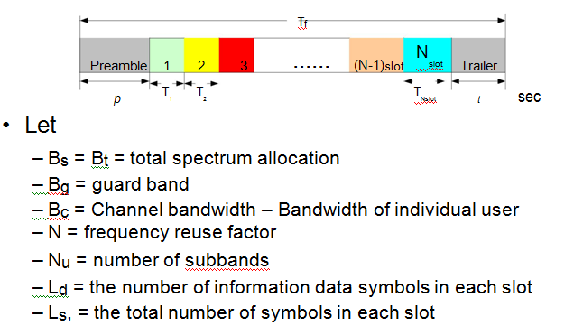

*Code Division Multiple Access*

* CDMA technology focuses primarily on the “DSSS” technique
* Instead of using freq or time slots, it uses digital codes to distinguish between multiple users
* Each user is assigned a ***unique PN code sequence***
* The assigned code is uncorrelated with the data
* Because the signals are distinguished by digital codes, many users can share the same bandwidth simultaneously

– i.e., signals are transmitted in the same frequency at the same time

* Multiplying the data by the high data rate PN code results in dividing the signal into smaller bits, thus, increasing its BW
* The PN code used for spreading must have

– low cross-correlation values and

– be unique to every user

*Advantages & Disadvantages*

**Advantages:**

1. **Voice Activities Cycles**

– CDMA is the only one technique that succeeds in taking advantage of the nature of human conversation

– In CDMA, all the users are sharing one radio channel

– The human voice activity cycle is 35%, the rest of the time we are listening

– Because each channel user is active just 35% of the entire cycle, all others benefit with less interference in a single CDMA radio channel

– So, the mutual interference is in a nice-free way, reduced by 65%; and thus, the channel capacity is increased about 3 times

**Improved call quality, with better and more consistent sound as compared to other systems**

1. **No Equalizer Needed**

– When the transmission rate is much higher than 10 kbps in both FDMA and TDMA, an equalizer is required

– On the other hand, CDMA only needs a correlator, which is cheaper than the equalizer

1. **No Hard Handoff**

– In CDMA, every cell uses the same radio

– This feature avoids the process of handoff from one freq to another while moving from one cell to another

1. **No Guard Time in CDMA**

– TDMA requires the use of guard time between time slots

* + - guard time does occupy the time interval for some info bits

– This “waste” of bits does not exists in CDMA, because guard time is not needed in CDMA technique

1. **Less Fading**

– Less fading is observed in the wide-band signal while propagating in a mobile ratio environment

1. **Capacity Advantage**

– Given correct parameters, CDMA can have as much as four times the TDMA capacity; and twenty times FDMA capacity per channel/cell

1. **No frequency management or assignment needed**

– In both, TDMA and FDMA, the frequency management is always a critical

– Since there is only one channel in CDMA, no frequency management is needed

1. **Enhanced privacy**

– CDMA signals resistant to interception or jamming

1. **Soft Capacity**

– Because in CDMA all the traffic channels share a single radio channel, we can add one additional user so the voice quality is just slightly degraded

1. **Coexistence**

– Both systems, analog and CDMA can operate in two different spectra, with no interference at all

1. **Simplified system planning through the use of the same frequency in every sector of every cell**

– Improved coverage characteristics, allowing for the possibility of fewer cell sites

1. **Increased talk time for portables**
2. **Bandwidth on demand**

**Disadvantages:**

1. **Capacity not well defined**

– The capacity of CDMA systems is not well defined. The effective (Eb/No) formula demonstrates the interference-limited nature of the system, but more than one factor in that formula is affected by the number of users, making it hard to gauge how performance degrades as a function of users

1. **The Near-Far Problem**

– The main problem with applying DS/CDMA is the so-called “Near-Far” effect

– This effect is present when an interfering Tx is much closer to the Rx than the intended Tx

– Assume there are 2 users, one near the base and one far from the base as shown

*Characteristic of DS/CDMA*

* **Universal Frequency Reuse**

– Uses one universal cell frequency reuse pattern applies

* + - This turns out to be beneficial and improves the capacity of the system
    - Ease of freq management is also found in DS/CDMA
* **Power Control**

– Reverse Link (from mobile unit to base station)

* + - link is designed to be asynchronous and is susceptible to the “near-far” problem
    - In order to remedy this, the use of power control is employed

– To ensure all signals from the mobiles with a given cell arrive at the base of the cell with equal power

– To maximize the total user capacity

– To minimize power consumption of portable units

* + Effective use of the power control will ensure that power control must be accurate and fast enough to compensate for fading

– Forward Link (from base station to mobile unit)

* + Link does not suffer much from near-far problem since all cell signals can be received at the mobile with equal power
  + When at excessive intercell interference, the power control can be applied by increasing the power to the mobile

**Direct Sequence Frequency Hopping Multiple Access (DS/FHMA)**

– One data bit is divided into frequency-hop channels (*fc*)

– In each frequency-hop channel one complete PN-code of length *NFH* is added to the data signal

– Since FH-sequence and PN-codes are coupled, every receiver is identified by a combination of an FH-sequence and PN-codes

